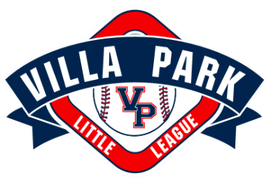
VLLA PARK LITTLE LEAGUE CODE OF CONDUCT
The Objective of Villa Park Little League is to implant firmly in the children of the community the ideals of good sportsmanship, honesty, loyalty, courage and respect for authority. To assist in achieving this objective, The Board of Directors for Villa Park Little League has mandated the following Code of Conduct for all Managers, Coaches, Game Officials, Players, Parents, Spectators and Volunteers.

Any Member, Manager, Coach, Official, Player, Parent, Spectator or Volunteer of VPLL shall:
- Not at any time, lay a hand upon, push, shove, strike or threaten to strike an Official, player, coach, or spectator.
- Not engage in verbal abuse upon any Game Official for any belief of a wrong decision or judgment call during a game.
- Not engage in an objectional demonstration of dissent at any time by the throwing of gloves, helmets, hats, balls, or any other forceful un-sportsman-like action.
- Not engage in the use of profane, obscene or vulgar language or gestures in any manner at any time.
- Not appear on the field of play, stands, or any other area designated to VPLL while intoxicated. Alcohol, Tobacco and Cannabis, or any other intoxicating substances/drugs are prohibited.
- Not smoke. Smoking is prohibited at all VPLL fields, games and events.
- Not engage in verbal discussion in a derogatory or abusive manner a play made or not by a player, or decision made or not by any Managers or Coaches during a game.
- Not publicly speak disrespectfully to any manager, coach, official, player or volunteer of VPLL.
- Not engage in tampering or manipulation of any league rosters, schedules, draft positions or selections, official score books, rankings, financial records or procedures.
- Agree to make every effort to arrive at all scheduled practices and games on time.
- Agree to treat fellow players, opponents, fans and umpires with respect.
- Agree to support and encourage all teammates and to always give my best effort on the field.
- Agree to respect coaching decisions regarding playing time, position and placement of players.
- Not coach any player from the stands.
My signature verifies that I have read, understand and agree to abide by this Code of Conduct. I further understand that failure to abide by this Code of Conduct may result in my removal from practice or a game, or ultimately removal from VPLL.

Signature________________________________________________ Date_______________________

